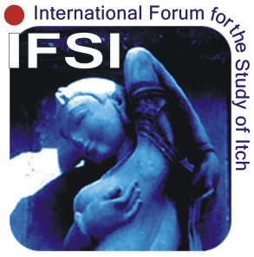
9th World Congress on Itch (WCI) 2017
October 15-17, 2017 in Wroclaw, Poland

Application Form for Travel Grant
Deadline: May 31st, 2017

Please fill in and send this form, together with a copy of the page of your passport showing your name and birth date, to elke.weisshaar@med.uni-heidelberg.de or +49 6221 565584

Last name: ______________________ First name:_____________________

Middle name (if any): __________________ Birth date:__________________

Are you an IFSI member?  Yes, I am  No, I am not

Affiliation:______________________________________________________

______________________________________________________________

Mailing address:  Office  Home

______________________________________________________________

______________________________________________________________

______________________________________________________________

E-mail address:__________________________________________________

Fax number:____________________________________________________

Title of the abstract submitted:

The organizer stores the information provided in this form only for the purpose of this application procedure. I understand that I do not have any legal rights against the decision of the organizer on the matter of this grant.

______________________________________________ _____________________
Your signature Date

